  - How to use e-PHAB
https://e-phab.org/login

- Log-into your account
Login: your email address
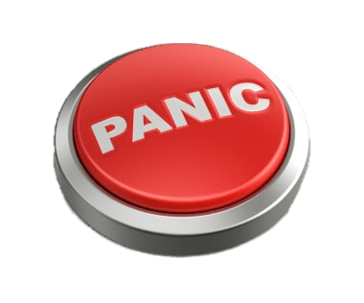
Password: password
If you encounter an issue, don’t get stressed; help is only a phone call / email away. Contact Mimi Ujiie, Accreditation Coordinator at 801-538-9065 / mimiu@utah.gov.
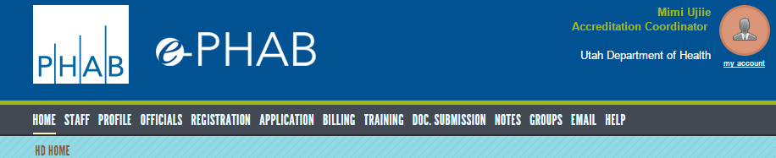
- Click on DOC. SUBMISSION

- Find your Measures & click on it
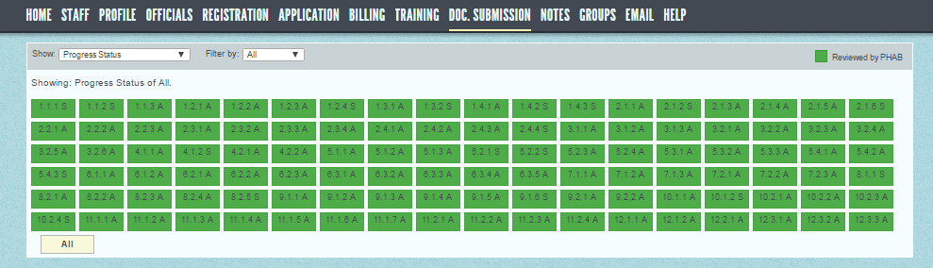

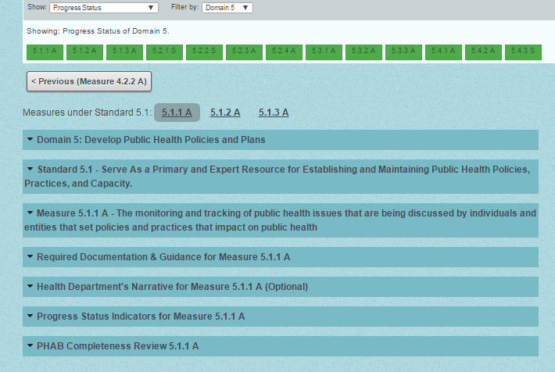
- Click on downward triangles to read about the Measure
What is the INTENT of the Standards & Measures?

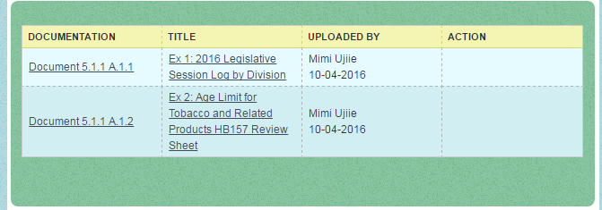
- Click on the documents to view/download
What kind of documents did we use to PROOF our conformity to the Measure?

