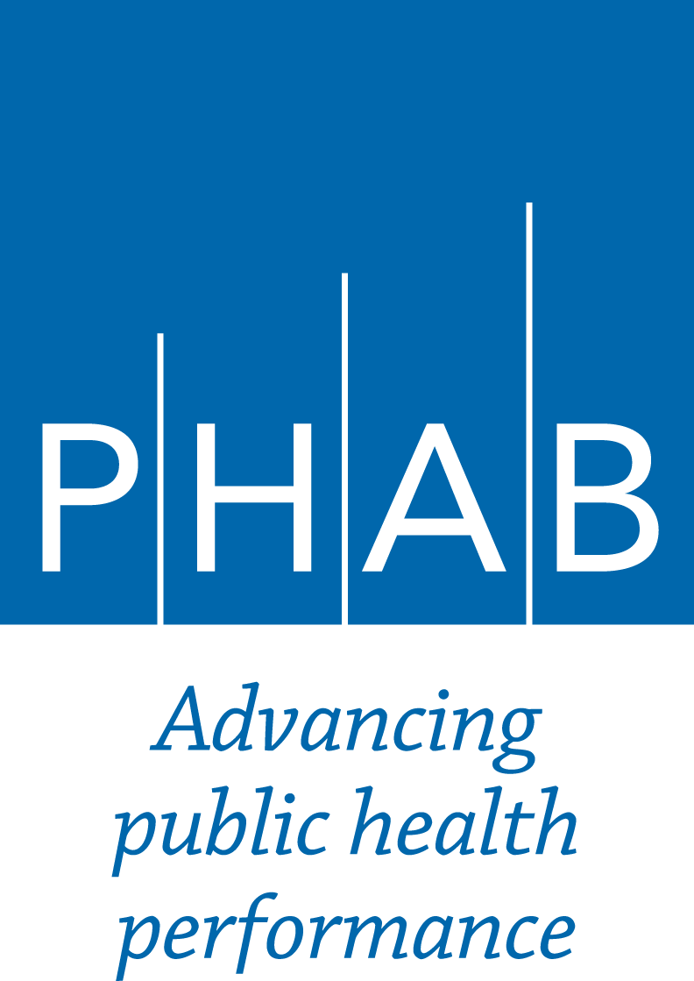 | PHAB Annual Report  Section II  First Annual Report After Initial Accreditation  Approval Date: July 2020; Effective Date: August 1, 2020

Due to the COVID-19 pandemic, the Annual Report template has been modified.
- Eight questions are completely optional. If you don’t have the time or capacity to address/answer these questions, please do not feel obligated to do so. It will not be held against the health department in any way.
- Questions 5-9 ask for a QI project, if you have a project related to your COVID-19 response, you can include it here.
- For questions such as 16, 17, 18, 19 – you can include descriptions of your current COVID-19 efforts. Perhaps some of those responses can be modified from documents/press releases/board of health reports that have already been created.

Your Annual Report will be reviewed, and you will receive feedback specific to your health department’s responses to this form. In addition, in order to help facilitate learning among accredited health departments, PHAB may take what we are learning from you and your peers, particularly related to COVID-19 response, to develop resources that are shared with all accredited health departments (for example, PHAB may develop resources identifying how COVID-19 related examples could be used for reaccreditation documentation).

On this form, you will report on the health department’s activities related to improvement; continuing processes; and emerging public health issues and innovations. Please provide brief responses to these questions. Each question should have a response of no more than 500 words. When you have completed this form, please log on to e-PHAB and upload this document. Upload the document as a Word file; do NOT convert it to a PDF.

There are different Section II forms for each year of the Annual Report process between initial accreditation and reaccreditation. Please be sure you are using the correct form.

Throughout this form you will see references to Reaccreditation Measures and required documentation (RD) in parentheses at the end of some questions. These questions are designed to help the health department begin thinking about the types of items that are addressed in the reaccreditation requirements. While the health department will receive feedback on the Annual Reports, it should not be interpreted as an assessment of conformity with any measure.

Health Department Name
Month and Year Submitted

Performance Management/Quality Improvement (PM/QI)
1) What internal and/or external factors have facilitated your health department’s progress in PM/QI since you were accredited? (Optional)
2) What internal and/or external factors have constrained your health department’s progress in PM/QI since you were accredited? (Optional)

3) The table below lists key components from the PHAB Reaccreditation Standards and Measures for Domain 9. Please complete the table below, to the best of your ability, to indicate the concrete steps the health department has taken since you were accredited to improve each element listed, the results of those steps, and one step it plans to take next year. If PM/QI activities have decreased due to COVID-19, please indicate if any work has been completed or planned.
Elements | Steps health department has taken since you were accredited | Results of those steps | Steps health department plans to take before next year’s Annual Report
Staff ownership of the performance management system (Measure 9.1 RD2.1)
Monitoring and revising PM implementation and measures (Measure 9.1 RD1.d & RD1.g)
Leadership support for performance management (Measure 9.1 RD3)
Revision of QI plan (Measure 9.2 RD1)
QI training (Measure 9.2 RD2.b)
Consideration of customer feedback (Measure 9.2 RD2.d)
Reporting results (Measure 9.1 RD1.e & Measure 9.2 RD2.e)
Institutionalized continuous quality improvement (Measure 9.2, RD5)

4) Did your health department track any QI projects related to the following areas since you were accredited? (Select all that apply. Place an X in the column to the left of the area.)
Data
Financial management
Workforce
Governance
Other administrative/management
Community engagement
Health equity
Programs
Other: please describe

Description of One QI Project
Select one formal QI project to describe in greater detail below.
5) How was the need for the QI project determined? Check all that apply.
Site Visitors/Site Visit Report
Accreditation Committee letter about accreditation status
Customer feedback
Performance management system
Health status gathered through community statistics, focus groups, etc.
Staff suggestion
Other: please describe
6) What is the existing effort or gap for which improvement is needed? What was the aim statement, including the specific measurable targets set for the activity?
If you have a storyboard that addresses all the following questions, you can upload the storyboard rather than responding questions 6-9 in this section.
7) What tools and implementation methods were used? Please describe what approach you used (e.g., PDCA, Lean), what tools you used (e.g., process mapping, fishbone diagram), how you determined root causes, and if you conducted a pilot.
8) What are the outcomes of the QI project, including progress towards the measurable targets that were set? Please provide specific data.
9) To which PHAB Reaccreditation measure(s), if any, does this QI project apply?

10) What PM/QI topics would you like guidance on? (Optional)
Gaining buy-in for QI
Finding and/or providing training on PM/QI
Sharing PM/QI information with staff and governing entity
Developing or revising QI plan
Assessing QI culture
Diffusing QI throughout health department
Determining when to implement a QI project
Implementing QI projects
Selecting performance measures
Tracking performance measures over time
Identifying resources
Working with data
Other: please describe
11) What specific questions do you have about PM/QI? If there is a particular question from this Annual Report form for which your health department would like feedback, please indicate it here. (Optional)

Continuing Processes to Prepare for Reaccreditation
12) Describe how your health department has strengthened its collaborative working relationships. The health department may provide narrative describing collaborative working relationships that have been established or maintained due to COVID-19. Provide one example of how you have strengthened relationships either
  - With community and partner organizations (including other sectors of the community such as the educational system, parks and recreation, health care, the faith community); or
  - With other levels of public health departments (Tribal, state, and local)?
13) Describe the ongoing community collaborative process for continuous enhancement of the community health assessment. In particular:
  - How does the health department determine which specific population groups with greater or particular health issues and health inequities to address? (Measure 1.1 RD2.b)
  - How does the health department identify and analyze factors that contribute to specific populations’ health issues (including social determinants of health and community factors or contributors)? (Measure 1.1 RD2.c & Measure 1.3 RD5)
If CHA activities have decreased due to COVID-19, please indicate if any work has been completed or planned.

14) Sharing Your Work - Please indicate how the health department has provided support to other health departments or shared its experiences with others outside of the department, related to quality improvement, performance management, or accreditation. (Select all that apply. Place an X in the column to the left of the activity.) (Optional)
 | Submitted an example to a national database of best practices |  | Gave a presentation at a meeting
 | Provided one-time consultation to staff at another health department |  | Provided ongoing assistance to staff at another health department
 | Published an article in a journal |  | None
 | Submitted a story to Accreditation Works! |  | Other (please specify):

15) Please describe one of the activities above (question 14) of which the health department is most proud. If the health department has published an article in a journal, please provide the citation below. (Optional)

Emerging Public Health Issues and Innovations
16) Has the health department conducted work in any of the following areas? (Select all that apply. Place an X in the column to the left of the issue.)
 | Data for decision making |  | Emerging infectious diseases (other than COVID-19)
 | Health equity |  | Climate change
 | Health strategist |  | Behavioral health
 | Public health financing modernization |  | Environmental bio-monitoring
 | Public health systems transformation |  | Genomics
 | Public health/health care integration |  | Adoption of emerging technology (specify)
 | Emergency preparedness and response (other than COVID-19) |  | COVID-19
 |  |  | Anti-racism
 | Community resilience |  | Other (please specify):

17) If the health department is engaged in work in an emerging area, such as COVID-19, please tell the story of the health department’s work in one area.
18) PHAB defines public health innovation as the creation and implementation of a novel process, policy, product, program, or system leading to improvements that impact health and equity.
Please describe the health department’s approach to pursuing innovation and any innovations that have emerged since you were accredited. (Optional)

Overall Improvements
19) Aside from what has previously been reported in this report, has the health department made any improvements that have had a significant impact on the health department or the community it serves in the past year? (Optional)
What has been the impact on the health department and/or the community? How was that impact measured? Please provide specific data, if available, to demonstrate measurable impact.

Reminders about Reaccreditation Preparation
Year 1: As you prepare for reaccreditation, here are some items you may want to focus on this year:
- Read reaccreditation guide (http://www.phaboard.org/wp-content/uploads/PHABGuideReacc.pdf)
- Watch training modules on Bridge, PHAB’s online learning center
- Begin building support for reaccreditation among the health department director and staff
- Continue to review the comments in the Site Visit Report from Initial Accreditation
- Review requirements that are new to Version 1.5 (http://www.phaboard.org/wp-content/uploads/Version-1.5-changes-and-clarifications-FINAL1.pdf)
- Prepare reaccreditation documents that need to be dated within 5 years (see reference document on Bridge)
- Read the template for the Annual Report for 2nd year after initial accreditation

